  DÉTECTIVE  ASSISTANT  NOM :  PRÉNOM(S) :  AGE : | FICHE VICTIME  Nom, Prénom :  Age :  Qui pourrait lui en vouloir ? _________________________________________________  _________________________________________________  _________________________________________________  Indices relevés sur place : __________________  _________________________________________________  _________________________________________________  _________________________________________________  _________________________________________________  _________________________________________________ | 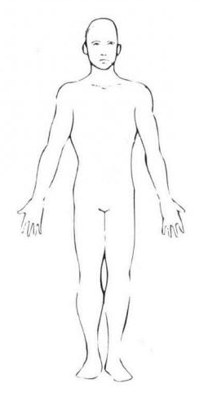  SCHEMA BLESSURES  SUR LE CORPS
ANALYSE D’INDICE  DÉTERMINE LA POINTURE DU SUSPECT  Seras-tu capable de calculer sa pointure ?  (Centimètres + 1) / 0.666 = pointure  Ex : (11cm + 1) / 0.666 = 18  12/0.666=18  Mesure de l’empreinte : (en cm) :  Calcul :  Résultat :  PORTRAIT ROBOT  D’UN SUSPECT | INFORMATIONS TÉMOINS  PRISE DE NOTES  _________________________________________________  _________________________________________________  _________________________________________________  _________________________________________________  _________________________________________________  _________________________________________________  _________________________________________________  _________________________________________________  _________________________________________________  _________________________________________________  _________________________________________________  _________________________________________________  _________________________________________________  _________________________________________________  INTERROGATOIRES SUSPECTS  PRISE DE NOTES  _________________________________________________  _________________________________________________  _________________________________________________  _________________________________________________  _________________________________________________  _________________________________________________  _________________________________________________  _________________________________________________  _________________________________________________  _________________________________________________  _________________________________________________  _________________________________________________  _________________________________________________  _________________________________________________ | INFORMATIONS TÉMOINS  PRISE DE NOTES  _________________________________________________  _________________________________________________  _________________________________________________  _________________________________________________  _________________________________________________  _________________________________________________  _________________________________________________  _________________________________________________  _________________________________________________  _________________________________________________  _________________________________________________  _________________________________________________  _________________________________________________  _________________________________________________  INTERROGATOIRES SUSPECTS  PRISE DE NOTES  _________________________________________________  _________________________________________________  _________________________________________________  _________________________________________________  _________________________________________________  _________________________________________________  _________________________________________________  _________________________________________________  _________________________________________________  _________________________________________________  _________________________________________________  _________________________________________________  _________________________________________________  _________________________________________________
  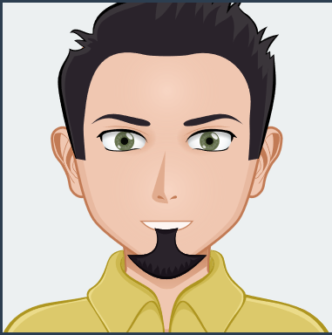  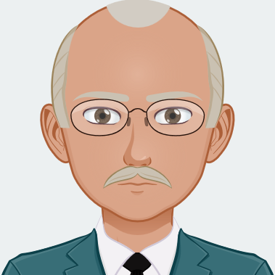  LISTE DES SUSPECTS A RAYER |     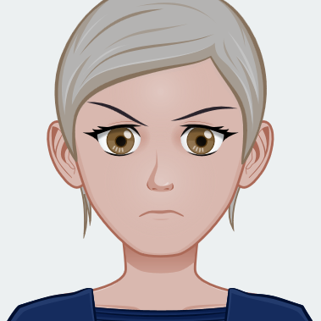      LISTE DES SUSPECTS A RAYER | QUI EST/SONT LE(S) COUPABLE(S) ?  D'après toi, que s'est-il passé ?

